PokeyMAX developers guide (for core version v1.26)
The PokeyMAX may contain several audio chips, depending on the version

Memory map
$D200-$D20F | Pokey1
$D210-$D21F | Pokey2/Configuration
$D220-$D22F | Pokey3
$D230-$D23F | Pokey4
$D240-$D25F | SID1
$D260-$D27F | SID2
$D280-$D283 | COVOX
$D284-$D29F | SAMPLE
$D2A0-$D2AF | PSG1
$D2B0-$D2BF | PSG2
$D2C0-$D2FF | RESERVED

Reduced memory maps

Mono (or any PokeyMAX when in mono mode)
$D200-$D20F | Pokey1
$D210-$D2FF | Shadows of Pokey1

Stereo
$D200-$D20F | Pokey1
$D210-$D21F | Pokey2/Configuration
$D220-$D2FF | Shadows of Pokey1, then Pokey2, then Pokey1 etc

Stereo with covox
$D200-$D20F | Pokey1
$D210-$D21F | Pokey2/Configuration
$D220-$D27F | Shadows of Pokey1, then Pokey2, then Pokey1 etc
$D280-$D29F | COVOX
$D2A0-$D2FF | Shadows of Covox

Quad
$D200-$D20F | Pokey1
$D210-$D21F | Pokey2/Configuration
$D220-$D22F | Pokey3
$D230-$D23F | Pokey4
$D240-$D2FF | Shadows of Pokey1, then Pokey2, then Pokey3, then Pokey4 etc

Quad with covox
$D200-$D20F | Pokey1
$D210-$D21F | Pokey2/Configuration
$D220-$D22F | Pokey3
$D230-$D23F | Pokey4
$D240-$D27F | Shadows of Pokey1, then Pokey2, then Pokey3, then Pokey4 etc
$D280-$D29F | COVOX
$D2A0-$D2FF | Shadows of Covox

Quad with sid
$D200-$D20F | Pokey1
$D210-$D21F | Pokey2/Configuration
$D220-$D22F | Pokey3
$D230-$D23F | Pokey4
$D240-$D25F | SID1
$D260-$D27F | SID2
$D280-$D2FF | Shadow of all above

Pokey registers
Please see wikipedia , Altirra hardware reference manual or Mapping the Atari etc
https://en.wikipedia.org/wiki/POKEY
http://www.virtualdub.org/downloads/Altirra%20Hardware%20Reference%20Manual.pdf
https://www.atariarchives.org/mapping/
IRQ is by default connected only on pokey1, though there is a register that allows all pokeys to be connected.
Pots/keyboard are only connected to pokey1.
Pokey 1 and pokey 3 go to the left channel (and internal channel).
Pokey 2 and pokey 4 go to the right channel.

SID registers
Please see the C64 wiki
https://www.c64-wiki.com/wiki/SID
Sid 1 goes to the left channel
Sid 2 goes to the right channel
Sid is clocked at a approximately 1MHz. It is an fraction of phi2. 5/9 phi2 in PAL mode, 4/7 phi2 in NTSC mode.

PSG registers
Please see the YM2149 data sheet or other PSG implementation. Note that the registers here are directly memory mapped.
i.e. you can simply read/write $D2A0 for R0 and $D2AF for RF
The PSG is clocked at 1MHz, 2MHz or PHI2.
1MHz is generated by 5/9 phi2 in PAL mode, 4/7 phi2 in NTSC mode.
2MHz is generated by 10/9 phi2 in PAL mode, 8/7 phi2 in NTSC mode.

The number of steps in the envelope can be switched between 16 and 32.
Also the stereo modes can be adjusted.
Mono: All channels to left and right
Polish (default): A+B to left, B+C to right. The same for both chips.
Czech mode: A+C to left, B+C to right. The same for both chips.
Max mode: PSG 1 to left, PSG 2 to right

COVOX registers

$D280 – VOLONLYCH1 – R/W
128 | 64 | 32 | 16 | 8 | 4 | 2 | 1
V | V | V | V | V | V | V | V
Default: 0

V
Unsigned(0-255) – Current channel volume. For cpu manual sample playing. Left channel.

$D281 – VOLONLYCH2– R/W
128 | 64 | 32 | 16 | 8 | 4 | 2 | 1
V | V | V | V | V | V | V | V
Default: 0

V
Unsigned(0-255) – Current channel volume. For cpu manual sample playing. Right channel.

$D282 – VOLONLYCH3 – R/W
128 | 64 | 32 | 16 | 8 | 4 | 2 | 1
V | V | V | V | V | V | V | V
Default: 0

V
Unsigned(0-255) – Current channel volume. For cpu manual sample playing. Right channel.

$D283 – VOLONLYCH4– R/W
128 | 64 | 32 | 16 | 8 | 4 | 2 | 1
V | V | V | V | V | V | V | V
Default: 0

V
Unsigned(0-255) – Current channel volume. For cpu manual sample playing. Left channel.

SAMPLE registers
The sample player is an extended version of covox. It plays via DMA from 42KiB of internal ram. The 6502 must manually load this internal ram, after which samples may be repeatedly played back from it.
There are 3 data formats:
- 4 bit signed
- 8 bit signed
- 4 bit ima adpcm, giving ~13bit quality. This may be created using for example sox under linux:
- sox -t wav some.wav -t ima -e ima-adpcm some.ima trim 0s 16384s
Sample rates up to 48KHz are supported (must higher is possible, but memory space is limited).
Samples are played by specifying a memory address, period, length and volume. The address and length are buffered, the period and volume are applied immediately.
When samples come to the end an irq is raised, which allows the next sample to be loaded into address and length. If a new sample has not been loaded the previous one is played.
The core clock speed is 2*phi2. So ~3.6MHz and varies with PAL/NTSC.
$D280-D283: See covox. Note that these are also updated by DMA from block ram, if enabled.

$D284 – RAMADDRL– R/W
128 | 64 | 32 | 16 | 8 | 4 | 2 | 1
L7 | L6 | L5 | L4 | L3 | L2 | L1 | L0
Default: 0

$D285 – RAMADDRH– R/W
128 | 64 | 32 | 16 | 8 | 4 | 2 | 1
L15 | L14 | L13 | L12 | L11 | L10 | L9 | L8
Default: 0

L0-15
Address in block ram, to read or write data

$D286 – RAMDATA– R/W
128 | 64 | 32 | 16 | 8 | 4 | 2 | 1
D | D | D | D | D | D | D | D

D
Read/write data from/to the internal memory, at the address specified by RAMADDR

$D287 – RAMDATAINC – W
128 | 64 | 32 | 16 | 8 | 4 | 2 | 1
D | D | D | D | D | D | D | D

D
Write data to the internal memory, at the address specified by RAMADDR. After each write the RAMADDR is incremented by 1.

$D288 – CHANSEL – W
128 | 64 | 32 | 16 | 8 | 4 | 2 | 1
X | X | X | X | X | C | C | C

Default:0

C
Select the channel to set the address/period/length/volume of
1: channel 1
2: channel 2
3: channel 3
4: channel 4
Other: reserved.

$D289 – SAMADDRL – W
128 | 64 | 32 | 16 | 8 | 4 | 2 | 1
L | L | L | L | L | L | L | L

$D28A – SAMADDRG – W
128 | 64 | 32 | 16 | 8 | 4 | 2 | 1
H | H | H | H | H | H | H | H

Default:0

L/H
Set the address of the sample for the channel selected in CHANSEL. This register is applied at the end of the current sample, or when dma state is changed.

$D28B – SAMLENL – W
128 | 64 | 32 | 16 | 8 | 4 | 2 | 1
L | L | L | L | L | L | L | L

$D28C – SAMLENG – W
128 | 64 | 32 | 16 | 8 | 4 | 2 | 1
H | H | H | H | H | H | H | H

Default:0

L/H
Set the length of the sample for the channel selected in CHANSEL. This register is applied at the end of the current sample, or when dma state is changed.
This length is specified in number of samples.
Length = L+H*256 +1

$D28D – SAMPERL – W
128 | 64 | 32 | 16 | 8 | 4 | 2 | 1
L | L | L | L | L | L | L | L

$D28E – SAMPERG – W
128 | 64 | 32 | 16 | 8 | 4 | 2 | 1
H | H | H | H | H | H | H | H

Default:0

L/H
Set the period of the sample for the channel selected in CHANSEL. This register is applied at the end of the current period.
The next sample is played after this period expires. 2*PHI2/(L+H*256).
i.e. this sets the rate of sample playback

$D28F – SAMVOL– W
128 | 64 | 32 | 16 | 8 | 4 | 2 | 1
X | X | V | V | V | V | V | V
Default:0

V
Set the volume from 0 (min) to 63 (max) for the channel selected in CHANSEL. The volume is linear.

$D290 – SAMDMA– W
128 | 64 | 32 | 16 | 8 | 4 | 2 | 1
X | X | X | X | D | D | D | D

Default:0

D
Enable DMA on a per channel basis.
XXX0 (0) = Channel 1 dma off
XXX1 (1) = Channel 1 dma on
XX1X (2) = Channel 2 dma on
X1XX (4) = Channel 3 dma on
1XXX (8) = Channel 4 dma on

$D291 – SAMIRQEN– R/W
128 | 64 | 32 | 16 | 8 | 4 | 2 | 1
X | X | X | X | I | I | I | I

Default:0

I
Enable IRQ on a per channel basis.
XXX0 (0) = Channel 1 irq off
XXX1 (1) = Channel 1 irq on
XX1X (2) = Channel 2 irq on
X1XX (4) = Channel 3 irq on
1XXX (8) = Channel 4 irq on

$D292 – SAMIRQACT – R/W
128 | 64 | 32 | 16 | 8 | 4 | 2 | 1
X | X | X | X | I | I | I | I

I
Read if IRQ is active per channel
Write 0 to clear IRQ on a per channel basis.
XXX1 (1) = Channel 1 irq active
XX1X (2) = Channel 2 irq active
X1XX (4) = Channel 3 irq active
1XXX (8) = Channel 4 irq active

$D293 – SAMCFG – R/W
128 | 64 | 32 | 16 | 8 | 4 | 2 | 1
B | B | B | B | A | A | A | A

Default: 0xf0

A
Enable IMA-ADPCM mode (16-bit sample encoded into 4-bits, approx 12-bit quality)
XXX1 (1) = Channel 1 adpcm mode
XX1X (2) = Channel 2 adpcm mode
X1XX (4) = Channel 3 adpcm mode
1XXX (8) = Channel 4 adpcm mode

B
The channels can be 8-bit (1) or 4-bit (0) quality.
XXX1 (16) = Channel 1 8-bit (0 for 4-bit)
XX1X (32) = Channel 2 8-bit
X1XX (64) = Channel 3 8-bit
1XXX (128) = Channel 4 8-bit

Configuration registers
Configuration registers may be accessed by bank switching it into the $D210-$D21F range. This is done by writing a special value of 0x3f to $D20c.
Reserved locations (X) must be written as 0. Reserved locations will read as 0.
The values to set are shown as X(Y) where X is the bit values (must be shifted into place) and Y is the decimal value.

$D210 –MODE – R/W
128 | 64 | 32 | 16 | 8 | 4 | 2 | 1
X | X | PAL | MonoDet | IRQEna | ChannelMode | X | Saturate
Miscellaneous settings
Default: 49

[Pokey] ChannelMode
0 (0) = Each pokey outputs as a separate ‘chip’
1 (4) = Output each pokey channel separately. E.g. channel 1 on AUD, channel 2 on audio pin 1, channel 3 on audio pin 2 and channel 4 on audio pin 3. In the case of multiple pokey chips, the channels are summed.

[Pokey] Saturate
0 (0) = Linear saturation curve
1(1) = Pokey saturation curve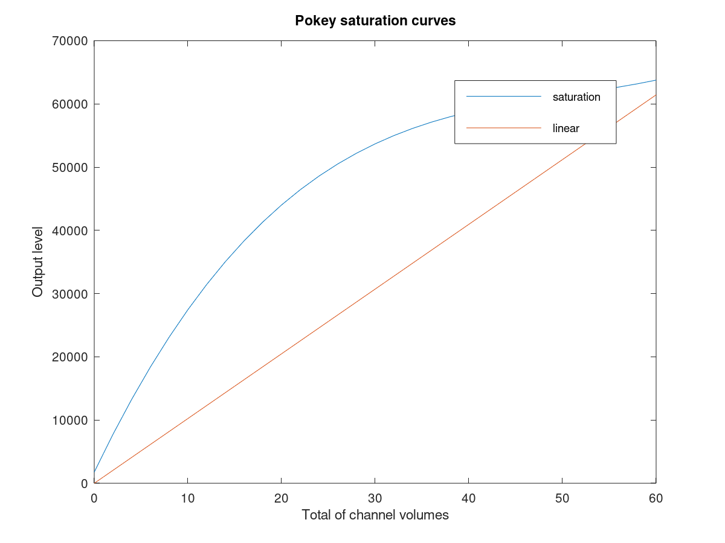
In future firmware revisions we anticipate allowing custom saturation curves.

IRQEna
0 (0) = Only pokey 1 irq is enabled
1(8) = All IRQs are enabled

MonoDet
0 (0) = Left channel to left, right channel to right
1(16) = When right channel is silent, play left on both left and right.

PAL
0 (0) = NTSC: Use 4/7 PHI2 multiplier for 1MHz clock
1(32) = PAL: Use 5/9 PHI2 multipler for 1MHz clock

$D211 – CAPABILITY - RO
128 | 64 | 32 | 16 | 8 | 4 | 2 | 1
X | FLASH | SAMPLE | COVOX | PSG | SID | Pokey | Pokey
Default: device specific

Pokey
00 (0) = Device contains a single pokey
01 (1) = Device contains two pokeys
10 (2) = Device contains four pokeys

SID
0(0) = Device does not contain a SID
1(4) = Device contains two SID chips

PSG
0(0) = Device does not contain a PSG
1(8) = Device contains two PSG chips

COVOX
0(0) = Device does not contain a COVOX
1(16) = Device contains four 8-bit COVOX manual volume registers

SAMPLE
0(0) = Device does not contain a sample player
1(32) = Device contains a block ram based sample player, with 32KB of memory

FLASH
0(0) = Device does not support reading or writing flash contents
1(64) = Device supports flash memory access (UFM and CFM)

$D212 – POSTDIVIDE – RW
128 | 64 | 32 | 16 | 8 | 4 | 2 | 1
CH3 | CH3 | CH2 | CH2 | CH1 | CH1 | CH0 | CH0
Default: 160
PokeyMAX natively outputs 0-5V on each audio output. A single audio chip at max volume will be 5V and at min volume 0V.
For internal output into the Atari pin 37 this is correct.
For line level output we want closer to 1V, this register allows us to achieve this by dividing selected channels by 2, 4 or 8, giving 0-2.5V, 0-1.25V or 0-0.0675V.
NB: When multiple devices are outputting at once, we could have a range of 0-10V, 0-20V or even 0-50V! Note that the pokeymax can natively only output 0-5V so anything above 5V will saturate. By using the /4 you will be able to have 4 devices at maximum volume with no distortion.

CH0
00(0) = /1
01(1) = /2
10(2) = /4
11(3) = /8

CH1
00(0) = /1
01(4) = /2
10(8) = /4
11(12) = /8

CH2
00(0) = /1
01(16) = /2
10(32) = /4
11(48) = /8

CH3
00(0) = /1
01(64) = /2
10(128) = /4
11(192) = /8

$D213 – GTIAEN - RW
128 | 64 | 32 | 16 | 8 | 4 | 2 | 1
X | X | X | X | CH3 | CH2 | CH1 | CH0
Default: 12
This register allows mixing gtia into the output channels.
Typically this is done for the channels actual to phono connectors and not for channels directly outputting into the system, since the motherboard already mixes gtia.

CH0
0(0)=gtia not included in channel 0
0(1)=gtia included in channel 0

CH1
0(0)=gtia not included in channel 1
1(2)=gtia included in channel 1

CH2
0(0)=gtia not included in channel 2
1(4)=gtia included in channel 2

CH3
0(0)=gtia not included in channel 3
1(8)=gtia included in channel 3

$D214 – VERSION – R/ VERSIONLOC –W

W
128 | 64 | 32 | 16 | 8 | 4 | 2 | 1
X | X | X | X | X | LOC | LOC | LOC
Default: 0

LOC
Write a value from 0-7 for the byte to read from the version string

R
128 | 64 | 32 | 16 | 8 | 4 | 2 | 1
CHAR | CHAR | CHAR | CHAR | CHAR | CHAR | CHAR | CHAR
Default: NA (depends on version!)

CHAR
Read a single character from the version string.
e.g. write 0, then read character 0, write 1 then read character 1 etc.

$D215 – PSGMODE - RW
128 | 64 | 32 | 16 | 8 | 4 | 2 | 1
X | VOLP | VOLP | ENV16 | STEREO | STEREO | FREQ | FREQ
Default: 4
This register allows changing settings for the PSG chips

FREQ
00(0)=2MHz
01(1)=1MHz
10(2)=1.7MHz
11(3)=reserved

STEREO
00(0)=mono. All channels of both chips to left and right
01(4)=Polish standard. A+B to left, B+C to right. For both chips.
10(8)=Czech standard. A+C to left, B+C to right. For both chips
11(12)=chip 1 to left, chip 2 to right.

ENV16
0(0)=32 step envelope
1(16)=16 step envelope

VOLP
00(0)=Log volume
11(96)=Linear volume
Space reserved for YM/AY3 curves.

$D216 – SIDMODE - RW
128 | 64 | 32 | 16 | 8 | 4 | 2 | 1
X | X | D2 | T2 | X | X | D1 | T1
Default: 17
This register allows changing settings for the SID chips. This changes the filter curve linear to approximate the very non-linear 6581 curve. It also changes the mixed waveforms and enables 6581 filter distortion. Digifix may also be enabled/disabled for the 8580.

T1 Sid 1
0(0)=8580 (linear filter)
1(1)=6581

D1 Sid 1
0(0)=digifix off
1(1)=digifix on

T2 Sid 2
0(0)=8580 (linear filter)
1(16)=6581

D2 Sid 2
0(0)=digifix off
1(32)=digifix on

$D217 – RESTRICT - RW
128 | 64 | 32 | 16 | 8 | 4 | 2 | 1
X | X | X | SAMPLE | PSG | SID | POKEY | POKEY
Default: 31
Allows disabling sound chips via software. This is used by the U1MB plugin.

POKEY
00(0)=Mono
01(1)=Stereo (if off area replaced by pokey1)
10(2)=Quad (if off area replaced by pokey1)

SID
0(0)=SID area replaced by pokey 1
1(4)=SID on

PSG
0(0)=PSG area replaced by pokey 1
1(8)=PSG on

SAMPLE
0(0)=COVOX/SAMPLE area replaced by pokey 1
1(8)=COVOX/SAMPLE on

$D218-$D21A RESERVED
Do not read or write

$D20C/$D21C – ID –R

$D20C/$D21C - CONFIG - W

W
128 | 64 | 32 | 16 | 8 | 4 | 2 | 1
CFGEN | CFGEN | CFGEN | CFGEN | CFGEN | CFGEN | CFGEN | CFGEN

CFGEN
00111111(63) –Map configuration into the $D210-$D21F memory area
Others values - $D210-$D21F is unchanged

R
128 | 64 | 32 | 16 | 8 | 4 | 2 | 1
ID | ID | ID | ID | ID | ID | ID | ID

Default: 1
ID
Returns 1 if pokeymax installed

FLASH
The following registers are only present if there is flash support. These are for Retronics use for updates. In 10M02 devices these are not supported. In 10M04 and 10M08 devices they are supported. Cores may be flashed or register defaults changed using the pokeycfg.xex program.
The flash is used for storing the FPGA core and register default contents. In future it will also be used for SID ‘corrupt’ mixed waveforms, volume curve data, SID filter curves and possibly some standard samples for the sample player.
The flash has a 32-bit parallel interface. See the Max10 flash guide for further details.

$D21B – FLASHOP –RW
128 | 64 | 32 | 16 | 8 | 4 | 2 | 1
X | X | A16 | A15 | A14 | CFG | REQ | R/W_N
Default:0

R/W_N
0(0)=write to flash data or cfg (must erase first)
1(1)=read from flash data or cfg

REQ
0(0)=Do not make a 32-bit wide request to the flash controller.
1(2)=Make a new 32-bit wide request to the flash controller. Once it is complete, REQ is cleared. For reads you can expect data to be available in the 32-bit FLASHDAT register by the next cycle. Writes/erases may takes longer. Writes takes data from the 32-bit FLASHDAT register.

CFG
0(0)=Access data area (i.e. main flash data).
1(4)=Access cfg area. This consists of two special registers in the max 10 for status, write protect and page/sector erase.

$D21D – FLASHADL -RW
128 | 64 | 32 | 16 | 8 | 4 | 2 | 1
A5 | A4 | A3 | A2 | A1 | A0 | WIN | WIN
Default:0
Read/write to bits 7 downto 0 of the flash address register.
WIN: Window into FLASHDAT (when combined with A15-A0 32-bit address effectively makes a virtual A17-A0 8-bit address)
A15-A0: Flash memory address

$D21E – FLASHADH - RW
128 | 64 | 32 | 16 | 8 | 4 | 2 | 1
A13 | A12 | A11 | A10 | A9 | A8 | A7 | A6
Default:0
Read/write to bits 15 downto 8 of the flash address register.

$D21F – FLASHDAT -RW
Default:0
Read/write from/to 8-bit window into 32-bit configuration register.
The address in the register is specified by the 2 low bits of FLASHADL.
Contents are changed either by the CPU or by a flash read operation.
On a flash write operation the contents of this register is written.

